IST 363

Lab 05

This Lab Covers
- Bootstrap Basics

Lab Corrections
- If you didn’t get a perfect score on the tailwind page in lab 4, check your corrections list comments in blackboad. Submit the url to your corrections for this part.

Warmup

  - Bootstrap Navigation: https://getbootstrap.com/docs/5.0/components/navbar/
What is the purpose of .navbar-toggler and .collapse in a Bootstrap navbar?
How can you align navigation items to the right within a navbar?
  - Bootstrap Buttons: https://getbootstrap.com/docs/5.0/components/buttons/
What are the size options for buttons in Bootstrap, and how are they applied?
  - Gutters
What are gutters in Bootstrap, and what is their default behavior?
What is a block button and where’s a situation where you might want that?

Bootstrap Page 1
- Portfolio Page
You will be creating the portfolio page (below) in Bootstrap. Do not write any regular CSS to create this page.
  - Page Size
This design is fixed width. It will not expand to fit 100% of the screen as you shown below. Everything on the page (nav, portfolio images, footer) display in fixed width and line up perfectly.

  - Portfolio Images
These should be perfectly lined up when you are done. Try to figure out my layout on your own.
  - Navigation: https://getbootstrap.com/docs/5.0/components/navbar/
Navs are put on the page inside the <nav> tag. Most navbars I make are customizations of the sample code from the documentation page. Check for the copy button (top right) to grab the example code. You will need to read about things like how to change alignment of text, etc.
Requirements for your navigation:
Make sure everything is coded with proper Bootstrap navigation classes. The camera is our navigation brand. Navigation should collapse and toggle at mobile size.
  - Buttons: https://getbootstrap.com/docs/5.0/components/buttons/
Both the buttons on your page change when rolled over. Here’s a screen shot of both with and without roll over.
 |  | Mouse Over Slightly Darker |  |  | Mouse Over Reverses Colors
 | 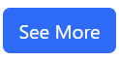 | 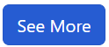 | 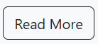 |  | 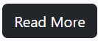
Desktop view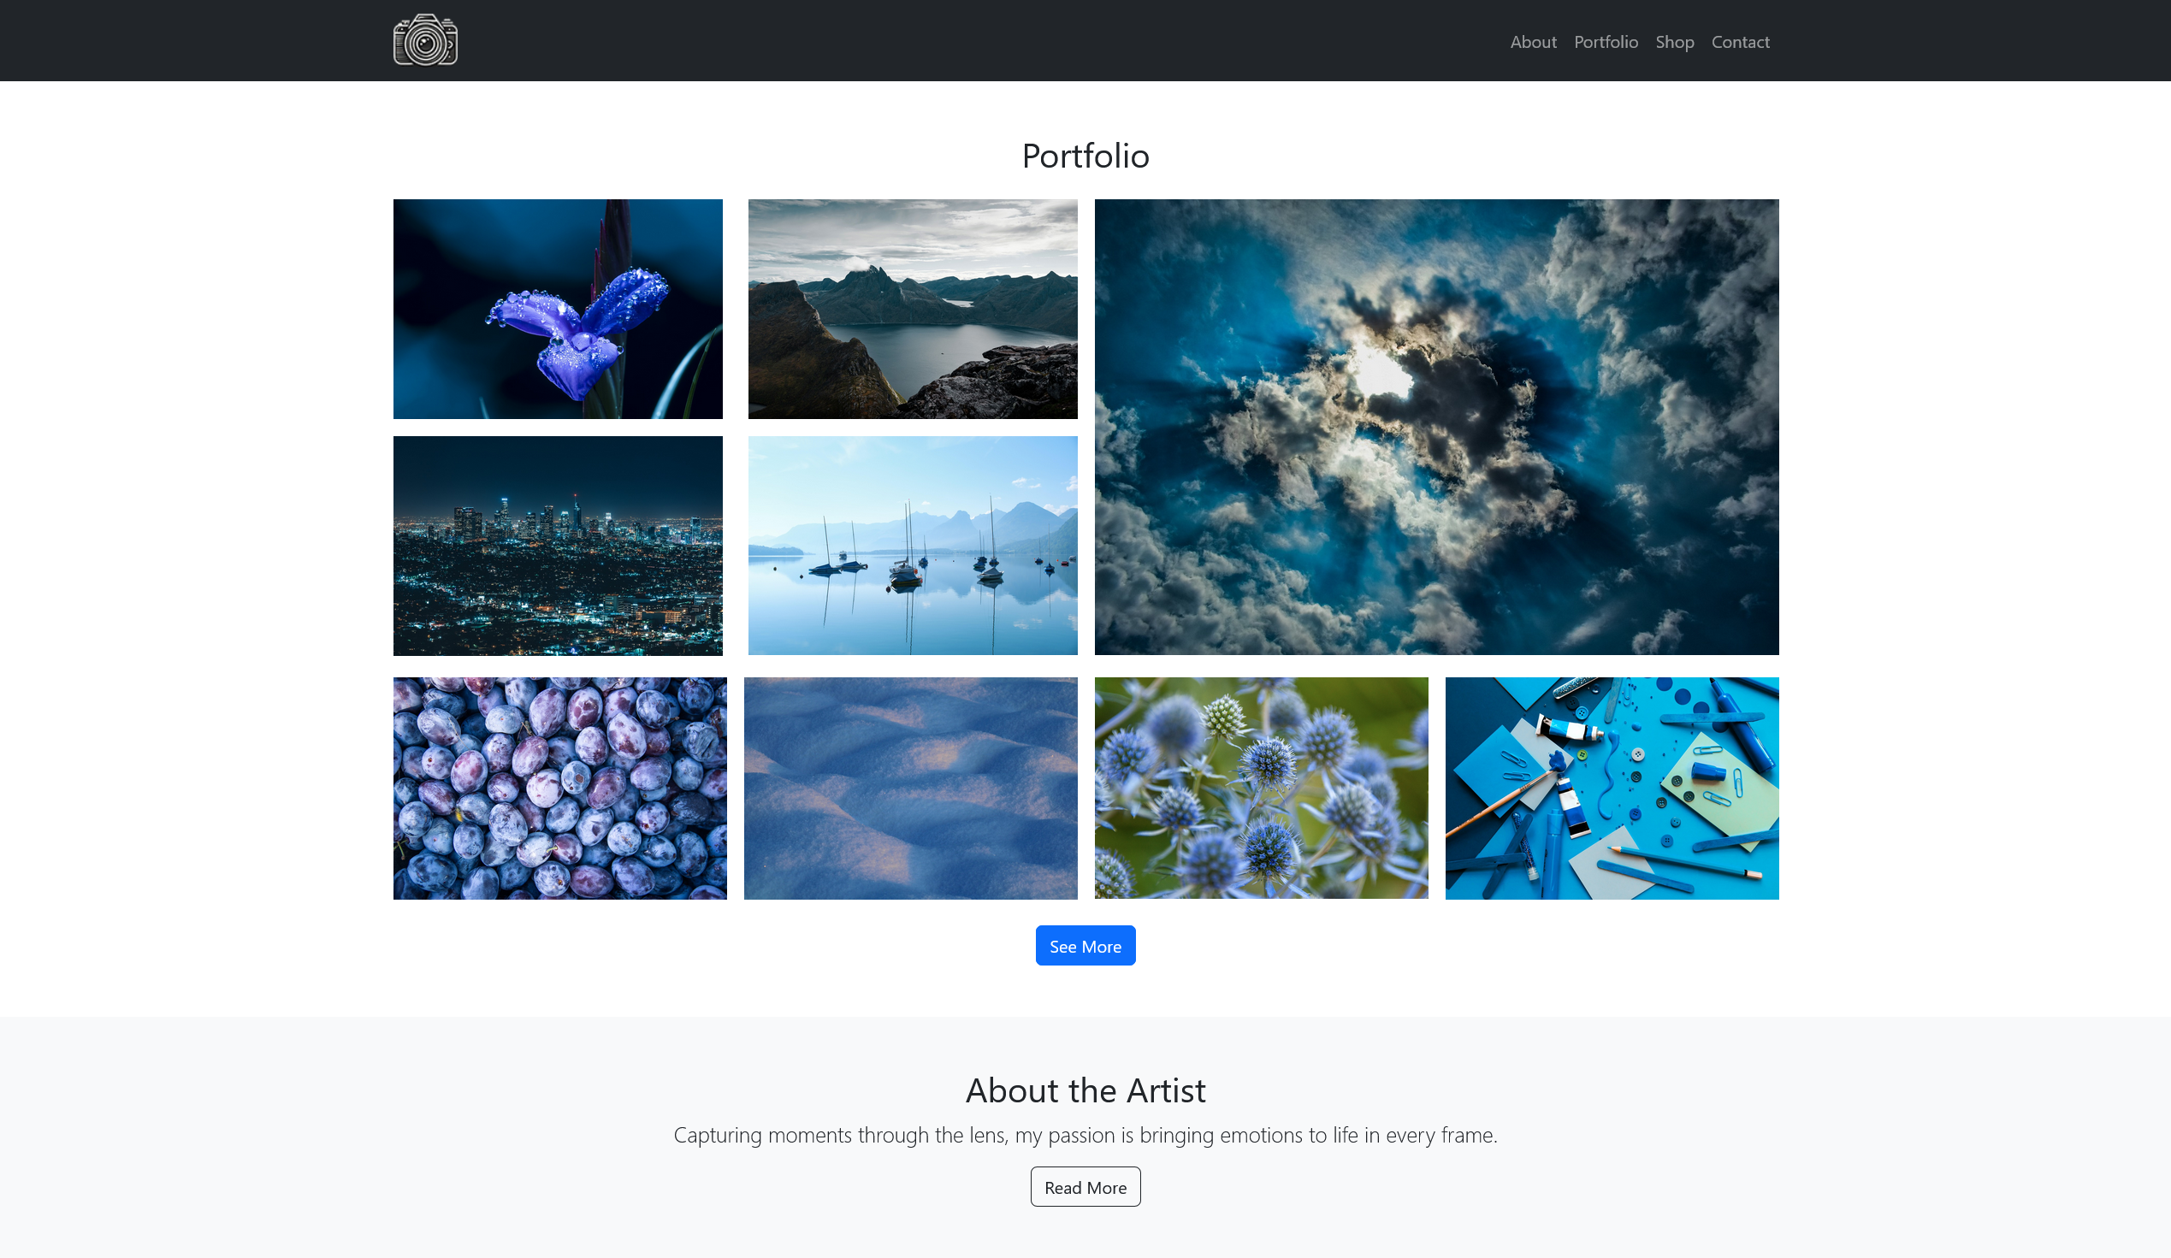
Mobile View
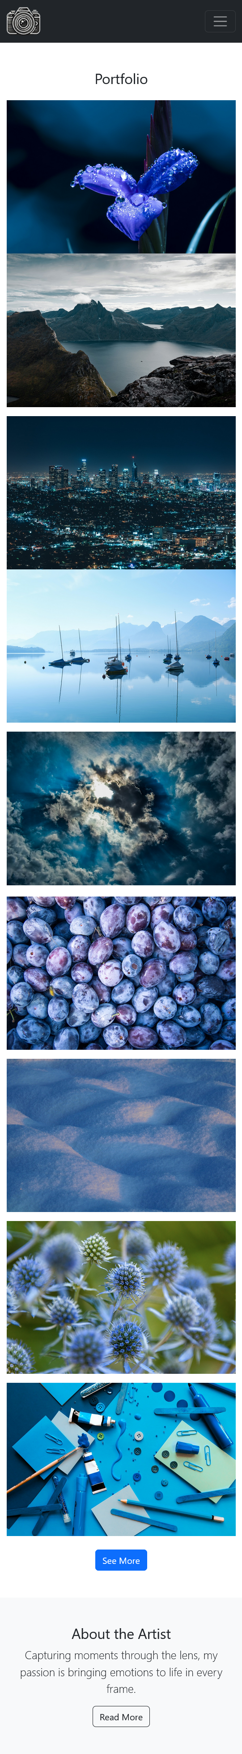

What to hand in
Note that if any URL doesn’t work for me, you will get a zero on this part. Ensure github.io is part of the URL in the address bar. If it’s not, you haven’t given me the correct link.
- For the corrections hand in the URL of the corrected page.
- For the warmup questions, paste your answers into the template provided in Blackboard.
- For the main page, hand in the URL
Use the answer template!

